Central TAFE
Software Information
Car Rental System

Modelling Group: Rodolfo Melanda Conde

Contents

Document Information 3
Document Revision History 3
Introduction 4
Development 4
Program Flow 5
Debugging 9
Sequential Access Algorithm 12
Open Source Tool 12

Document Information

Category | Information
Document | Car Rental System Requirement Specifications.
Issue | Version 1.0
Lead Author | Rodolfo Melanda Conde
Status | Version 1.0
Identifier
Reviewer (initial) | Rodolfo Melanda Conde
Reviewer (final) | Andrew Samway

Document Revision History

Date | Issue | Description | Author
May 05, 2016 | 0.1 | Start of Documentation | Rodolfo Melanda Conde
May 05, 2016 | 0.2 | End of Documentation | Rodolfo Melanda Conde
Software Requirements Specifications
Car Rental System

Introduction

Andrew Samway has given approval to commence work on the Car Rental System project. The project’s aim is to store the fleet details and all rent information on the fleet. The system will record:

- Car model;
- Car Manufacturer;
- Manufacture Year;
- Total KM travelled;
- Total Services;
- Total fuel expense;
- Number of days that the car has been rented;
- Number of times that the car has been rented (Journeys).

Development

The development of the Car Rental System will take place at Central TAFE Institute of Technology Classrooms. NetBeans have been chosen as the development environment and Java as the language for creation of this Car Rental System.

Program Flow

- Main menu
The image bellow shows the main menu that is displayed as soon as the program starts.
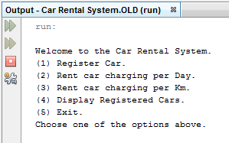

- Registering a car
By selecting the “Register Car” option (typing 1), the program asks the user to input the manufacturer, model and year of the car.
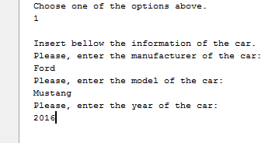

- Renting the car
After registering the car, the program displays the main menu again and then the user can choose between renting per day or per KMs. By selecting any of the two options, the program will display for renting all the registered cars.
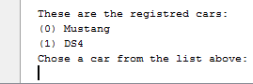

  - Renting per Day
If per day is selected, after selecting a car from the list, the program will ask the user to input the amount of days and KMs that were travelled.
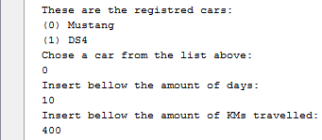

After receiving the user input, the program load the main menu again.

3.2 Renting per Km
If per KMs is selected, after selecting a car from the list, the program will ask the user to input the amount of KMs that were travelled.
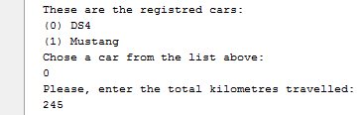

After receiving the user input, the program load the main menu again.
- Display Registered Cars and it`s Information
By selecting the fourth option of the main menu, the information of all the registered cars is printed.
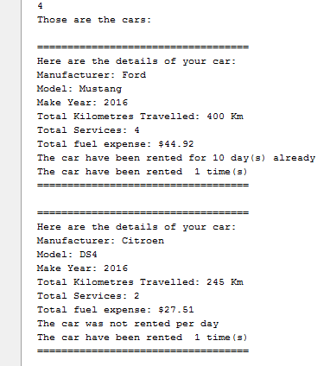

After printing all the cars, the program load the main menu again.

- Exit
By selecting the fifth option of the menu, the program exits.
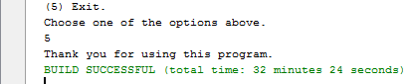

- Extra Actions
Not Rented:
Total Kilometres Travelled, Services, fuel expense and additional message at the end saying that the car hasn’t been rented.
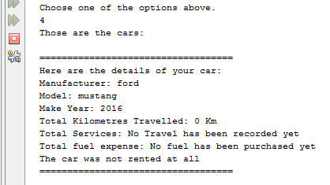

No cars registered:

Selecting the wrong option on the main menu:
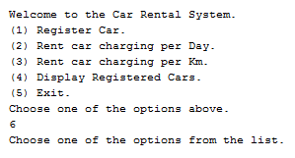

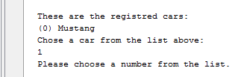
Selecting a car that is not on the list:

Debugging

A number of errors have happened and were fixed, but as the project grew some of them were not registered and the ones about to be displayed are not ordered sequentially.

Selecting a car from the list of registered cars:
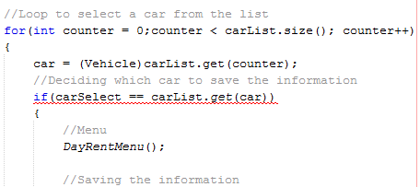
Error:

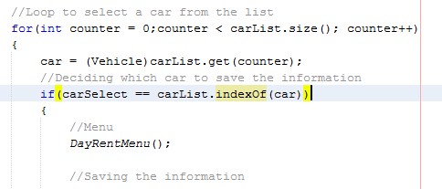
Fix:

Because of a syntax error, the condition was not able to compare the selected car with the cars on the list.
Setters and Getters Errors:
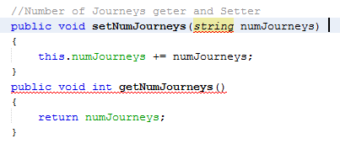
Errors:

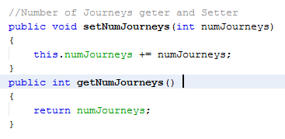
Fixes:

On the set method, the parameter was declared as a string, but it was supposed to be an integer, because it will store a number of Journeys.
The get method had a void, which should not return a value, but it was returning the number of Journeys, so removing the void keyword fixed the problem.
Not printing the registered cars:

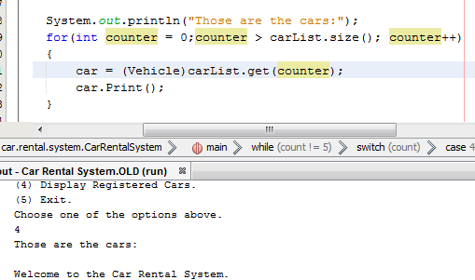
Error:

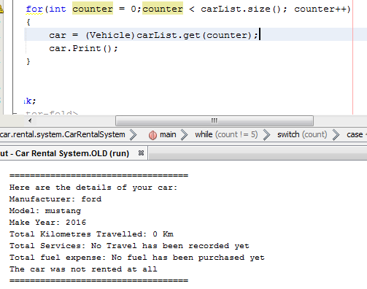
Fix:

The wrong operator caused the search to be invalid, so replacing the “>” with the “<” operator fixed the problem.

Sequential Access Algorithm

A for loop was used to access the information on the Array List, which contained the information of the cars: model, manufacturer, year, total km, fuel expenses, days rented and journeys.
Inside the for loop, a counter was created so it could be used to access the positions of the array list. It was initialized as zero and it was incremented after each time it was looped. The loop runs while the size of the counter is lesser than the size of the array list (number of the cars registered). At the end of each loop, a print method is called and it prints the all information of the car on the selected position (counter’s actual position).

Open Source Tool

GitHub was selected as the Open Source tool and the link to the project is:
https://github.com/CondeRodolfo/CarRentalSystem

